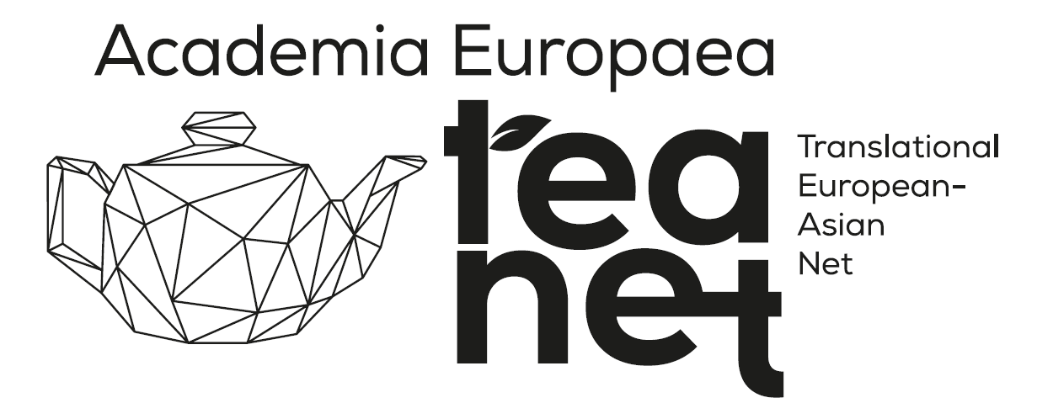

**APPLICATION FORM FOR COLLABORATIVE OPPORTUNITIES**

[**https://forms.gle/SVTKtLkqmwyJFfBD9**](https://forms.gle/SVTKtLkqmwyJFfBD9)

**YOU CAN SUBMIT IT ONLY ONLINE**

1. **Personal Information**

Photo

1. Full Name:
2. Male/Female:
3. DOB:
4. Title/Position:
5. Affiliation/Institution:
6. Email Address:
7. Phone Number:
8. Address:
9. MAE Membership: (yes/no)
10. YAE Membership: (yes/no)
11. NASE Membership: (yes/no)
12. SU CTM Membership (yes/no)

MAE: Member of Academia Europaea

YAE: Member of Young Academy of Europaea

NASE: National Academy of Scientist Educations

SU CTM: Semmelweis University Centre for Translational Medicine

1. **Professional Background**
2. Degree:
3. Area of Expertise:
4. Key Research Interests (max. 250 words):
5. Notable Publications (please list up to five):
6. H-index (Scopus: if known):
7. Total Citations (Scopus: if known):
8. **Collaboration Interests**
9. What specific topics or fields are you interested in collaborating on? (max. 250 words):
10. Please specify your interests (tick all the relevant options):

* Bilateral research projects and research grant application
* Bilateral educational projects (MSc, PhD)
* Co-authoring publications
* Organizing/participating in workshops and conferences
* Technology transfer and innovation
* Hosting visiting researchers/students (short-term)
* Hosting visiting researchers/students (long-term)
* Sending visiting researchers/students (short-term)
* Sending visiting researchers/students (long-term)
* Working abroad (short-term)
* Working abroad (long-term)
* Other (please specify)

1. Do you have a specific project idea in mind? If yes, please provide a brief description (max 250 words).
2. What are your expected outcomes of the collaboration? (tick all the relevant options):

* Publications
* Patents
* Grants and funding
* New methodologies or technologies

- Student and Researcher Exchange

- Other (please specify)

5. Are you interested in sending your students to a partner institution for (tick all the relevant options):

- PhD programs

- MSc programs

- Short-term research visits

- Long-term research visits

6. Are you interested in hosting students from a partner institution for (tick all the relevant options)

- PhD programs

- MSc programs

- Short-term research visits

- Long-term research visits

7. Are you interested in visiting a partner institution yourself for (tick all the relevant options):

- Short-term research visits

- Long-term research visits

1. **Funding and Resources**

1. Do you have access to funding for international collaborations?

- YES

If yes, please specify the source:

- NO

2. Are you seeking funding through this collaboration? If yes, what type of funding?

- YES

If yes, please specify the source/form.

- NO

3. What types of grant opportunities are you interested in? (tick all the relevant options)

- Basic research grants

- Applied/Translational research grants

- Innovation and technology transfer grants

- Educational and training grants

- Mobility and exchange grants

- Infrastructure and equipment grants

- Other (please specify)

4. Where would you prefer to utilize the grant funds? (tick the relevant option)

- Europe

- Asia

- Both continents

- Other (please specify)

**V. Collaboration Logistics**

1. What is your preferred mode of communication and collaboration?

- Email

- Video conferencing

- In-person meetings

- Other (please specify)

2. If financial resources are available, would you be willing to travel to an Asian partner institution for initiating the collaboration in 2025?

- Yes

- No

1. **Additional information**

1. Please provide any additional information or comments that could help us facilitate this collaboration. (max 250 words).

1. **Data Sharing and GDPR Compliance**
2. I consent to my personal data being shared within the TEA-NET partners for the purpose of facilitating collaborative opportunities. I understand that my data will be handled in accordance with GDPR regulations and will only be used for the purposes specified in this application.

- Yes

- No

1. **Declaration**
2. I hereby declare that the information provided is true and correct to the best of my knowledge.

- Yes

- No